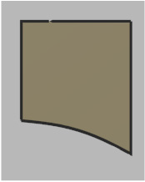
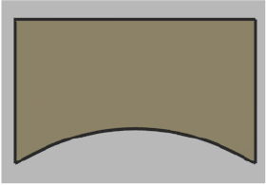
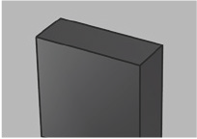
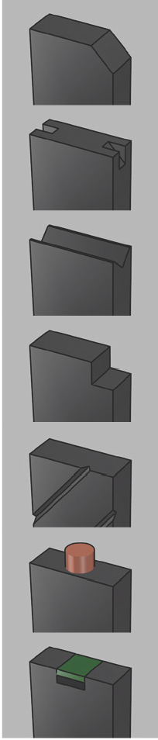
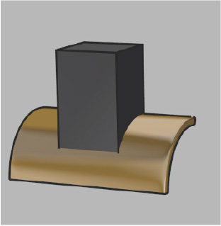
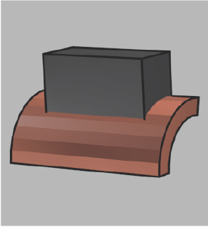
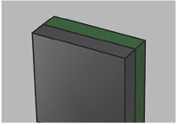
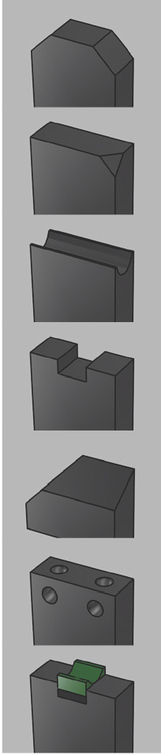
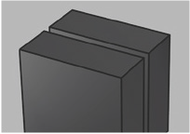

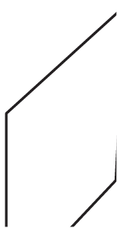

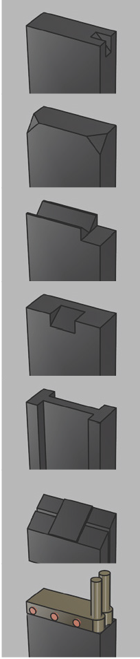
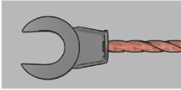
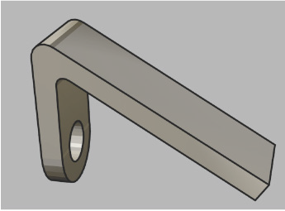
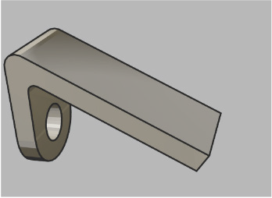
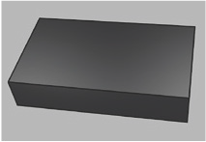
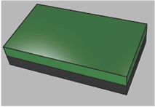
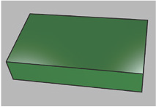
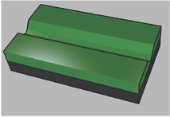
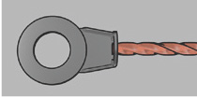
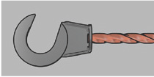
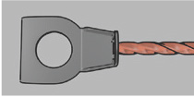
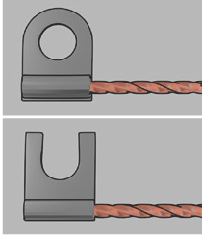
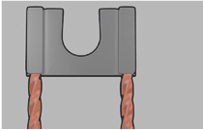
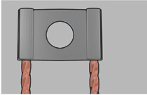
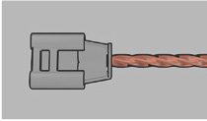
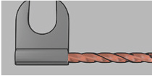
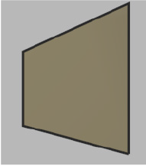






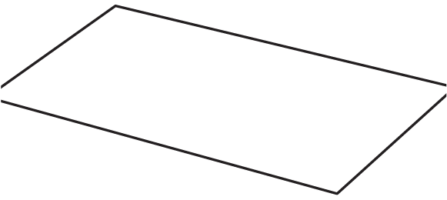


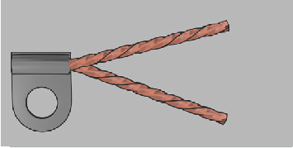







Contact surface area (R) if required

R
B
A
R
If radius is not known please contact us
A
B R
r
r
t
a
T˚
B˚
COMMUTATOR
T
R
T˚
a

A B C D
E F G H
I

J

Stud/Gap Size
If top and bottom bevels are required please state angles
BRUSH DIMENSIONS
SLIPRING
B˚
t
A
New/Worn
Quantity Required Material / Grade
CUSTOMER NAME: ADDRESS:

TEL:
FAX:
CONTACT NAME:
DATE:
ORDER NO:
POST CODE:
Unit C2, Kingsland Trading Estate, St Philips Rd, Bristol BS2 0JZ enquiries@mawdsleysber.com
0117 955 2481
ADDITIONAL INFORMATION
MOTOR DETAILS
RADIUS
TERMINAL
FLEX STYLE
BASIC SHAPES
CUSTOMER DETAILS
FITTINGS
METAL PLATES
b  b |  |  |  | a  a | A  B
 | FIBRE |  |  | RUBBER
 |  | C | a | b | D
FIBRE/RUBBER WITH GROOVE
 |  | E |  |  | F
Fitting Dimensions (mm)

a b

A B C
PLAIN | LAMINATED | PAIRS
1 2 3

4 5 6

7 8 9

10 11 12

13 14 15

16 17 18

19 20 21

Please tick box(es) to indicate ﬂex positions. (Single brush or one of a pair illustrated)
B C
A I F
E
D
G H

When quoting ﬂex lengths, please measure from the top of the brush to the centre of the terminal as illustrated.
L (mm)
Length (mm) | Dia. (mm)
Insulated    YES NO | Rivetted    YES NO
Material

Plain Copper Tinned

Manufacturer
HP / KW
Motor Type
AC DC

ORDER/QUOTE FORM

